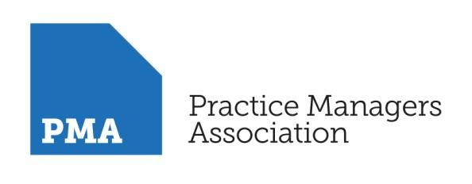

THE BUSINESS OF GENERAL PRACTICE

MODULE: HR & EMPLOYMENT ISSUES –

HR, EMPLOYMENT LAW, PERFORMANCE MANAGEMENT

AND CHANGING STAFF BEHAVIOUR

Dates: 8th December 2021

Session 1: 9.00am – 11.00am

Session 2: 11.30am – 1.30pm

Dates: 15th December 2021

Session 3: 9.30am – 11.00am

Cornwall Training Hub
This web workshop will be held on MS Teams, if you are interested in attending this session, please send the following details listed below to jenny@practicemanagersuk.org in order to register for this session:
- Full name
- Title and date of web workshop you want to book onto
- Email

Overview
This programme focuses on the HR, employment and people issues that regularly arise in general practice. We will cover employment law in an interactive way with practical guidance to enable participants to manage more effectively their human resource and deal with staffing challenges. There will be an update on the changes in the employment and legislative frameworks that will affect practices and employers.

The web workshop also includes a look at employment models for PCN staff and liability implications for practices – this includes TUPE and or where necessary redundancy – when practices are looking at merging, partnering or taking over a practice. The workshop will provide the practical guidance on how to manage the likely changes resulting from the new models of delivering GP services.

The module will be delivered as interactive web workshop sessions with practical guidance to enable participants to map the techniques and outcomes onto their own practice.

Objectives
Participants will improve their understanding of the contractual and legal requirements of staff employment and will also receive frameworks for managing staff behaviour. This will include:

- HR & Staff Management
- Employment status and employment contracts
- Legislative changes (payslips, national living wage, tax treatment of notice pay)
- Holiday pay, sick pay and overtime
- Discrimination and Equality, including sexual harassment in the workplace and family friendly rights
- How to manage contracts, probationary periods and staff induction.
- Information Governance, GDPR & Data Protection – any Brexit implications?
- Performance Management – Skills and behaviour
  - Dismissal, Unfair dismissal, discipline & the ACAS code
- Constructive dismissal (including bullying at work)
- Grievances and how to handle them correctly
- Working time issues (including holiday issues)
- Managing sickness, absence and return to work
- Family-friendly rights
- Work Life Balance, Mental Health & well-being in the workplace
- The dangers of social media in and out of the workplace
Programme information
Web workshop - Session One
Introduction and Welcome
- Programme
- Objectives
- Open Forum
Employment Law
- Employment law update 2020
- Post Covid changes

Working at scale
- Working at Scale
- TUPE
- Redundancy
- Shared Contracts

BREAK
Web workshop - Session Two
Recruitment & Performance Management
- Recruitment and selection
- Discrimination and Equality, including sexual harassment
- Probationary periods and staff induction.
- Performance Management – Skills and behaviour
  - Dismissal, Unfair dismissal, discipline & the ACAS code
  - Constructive dismissal (including bullying at work)

Performance Management
- Performance Management – Skills and behaviour
  - Grievances and how to handle them correctly
  - Working time issues (including holiday issues)
  - Managing sickness, absence and return to work

Open Discussion

CLOSE

Web workshop - Session Three
Absence Management & Stress
- Absence Management
- Wellbeing & Stress Management
- Social Media
Open Forum - questions and discussion
CLOSE

About the Facilitator - Ali Moran FCIPD, Employment Law Specialist

Ali is an experienced HR professional who delivers pragmatic and relevant advice and guidance on how to get the best out of your employees whilst staying within the law and mitigating risk. She works at both strategic and operational level, delivering focused and results-orientated training and advice, underpinned by a master’s degree in Employment Law. Ali has lectured in employment law at under-graduate and post-graduate level in addition to delivering presentations to businesses of all sectors nationwide for several years.

Specialties: Employment law advice; HR best practice; HR policies; performance management; conducting investigations; managing disciplinary and grievances; delivering seminars/training.

