GENERAL
PRACTICE
HANDBOOK FOR STUDENT NURSES
SURGERY:
WELCOME TO OUR SURGERY
The whole of our Practice team are looking forward to welcoming you to your student nurse placement. We are working with Plymouth University and the Cornwall Primary Care Training Hub, with a view to developing learning opportunities in General Practices for Pre-Registration Nurses.
The aim is to provide Student Nurses with first-hand experience of
Primary Care and give them the opportunity to work alongside Registered Nurses, GPs, other nursing team members, and the wider Primary Care Team.
The placement will offer high quality learning and will provide the student with an understanding of the complexities and diverse work undertaken in Primary Care with the objective of providing each student with an enjoyable and rewarding experience, and hopefully encourage a future career in primary care nursing. The following information in this handbook is included to provide a comprehensive and contractive schedule, as well as overall guidance in protocols and policies whilst undergoing student training at the Practice. We understand you will have objectives to fulfil while you are here and this will help to form structure to your placement as there are so many components to practice nursing. Please log onto our website to gain some background information on the practice, the team, and the services we provide:
WEBSITE ADDRESS:

Student Nurse Support
During your placement at the Practice, you will be supported by your
Assessor................................................, the Lead
nurse………......................... the Cornwall Primary Care Training
Hub.....................................................and your university link……….....................................................................................

Uniform Policy
The student is required to wear their uniform, always presenting a professional image whilst on duty. It is the student’s responsibility to ensure that their uniform is clean and presentable following the ‘bare below the elbows’ standard procedure. You should always wear your name badge while on duty.

Sickness and Absence
Should a student be absent for any reason, it is their responsibility to inform both the University and the Practice at which they are placed. This must be done as soon as they know that they are unable to attend work. Please refer to the University’s procedure for reporting sickness and absence. The Practice will also have a policy for sickness and absence reporting which the student must adhere to. In brief, you should telephone …….........................
Contact …................................ (Head of Dept) on …....................…..
Contact ....................................(Manager) on .................................... as soon as practicable (ie night/day before) and no later than between 7:30 – 8:15am for that day’s duty to report in sick.
The surgery telephone number for reporting sickness within working hours is ............................................................ 8.30am – 6.30pm.
Both organisations will require updates concerning duration of absences and planned return dates.

Policies
As part of your induction, it is important to familiarise yourself with your Surgery policies. These set out specific expectations from the surgery and from the Student to enable active learning in a safe environment.
These can be found in..............................................………………….
Health and Safety
Uniform
Confidentiality
Infection Control
Sickness and Absence

Confidentiality
The Practice Manager will ask all students to sign a confidentiality agreement whilst working at the Practice. Any breaches will be fully investigated and could lead to disciplinary action/cessation of placement.

Health and Safety
Whilst undergoing training at the Practice, the student will be made aware of and will adhere to the Health and Safety Policy. It is the student’s responsibility to ask for any assistance regarding Health and Safety issues, should they be required. If you witness any breach to health and safety this should reported to your assessor or the supervisor you are working with.
Prior to starting any clinics, the student will undertake the Health &
Safety Induction with the Asst. Practice Manager – this will include:
Prior to starting any clinics, the student will undertake the Health & Safety Induction with a member of the Management team.
This will include:
First Aid - location of First Aid box in emergency cupboard Accident Reporting and Accident Book - location in reception area.
Secondary tour of the building explaining all the locations for fire extinguishers,
Emergency exits, all fire call points to sound bells and the location outside in the car park
When the building has been evacuated
Fire Plan and full explanation of emergency procedures on finding a fire
Display screen/VDU workstation information and assessment Significant event procedure and how to record any events.
Manual handling/lifting (define responsibilities/limits)
Hand Washing Policy
Handling samples received from patients.
New members of staff employed in the Dispensary or Clinical Teams will require further induction from their Head of Dept regarding infection control, PPE, uniform policies etc.

Infection Control
It is the Practice’s responsibility to provide the student with the correct equipment and resources to adhere to the required standards of infection control. The Practice undertakes infection control audits, which you might be part of during your placement. If you notice any breach of infection control this should be reported to your Assessor/ Supervisor or Infection control lead. You should have a full induction for the special measures of IPC due to the COVID-19 Pandemic and ensure you have access to all required PPE.

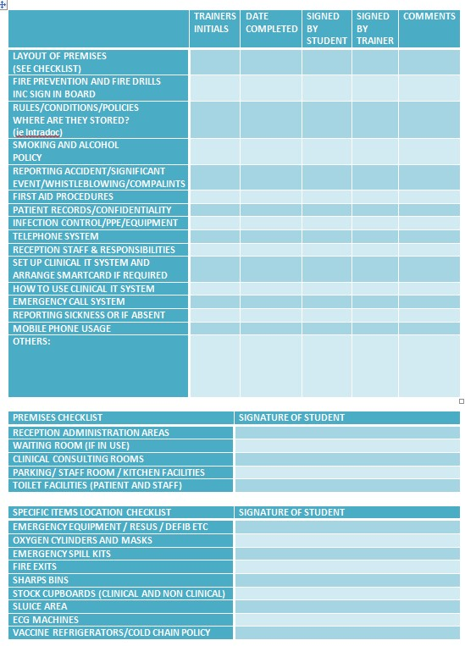

CLINICAL PLACEMENT INFO:
Assessor:
Days Available:
Supervisors:
Other nursing team members who you will work with:
Placement dates:
Initial, mid-point and end point assessment dates agreed:
Initial date :
Mid point date :
End point :

CLINICAL AREAS
This list is intended to be a guide to be used by the Assessor and student to ensure the student is involved in a wide range of duties during the placement.
Note: Student Nurses must always be supervised by a Registered Nurse but can work with other members of the team. If you have any queries on student competencies, contact the University Link Lecturer.
Treatment Room:
The assessment and management of patients presenting with injuries
Wound care – acute/ chronic/ surgical
Leg assessments/ Dopplers
Aseptic and clean techniques
Observing the management of patients presenting with medical emergencies
24-hour blood pressure monitors
24-hour ECG monitoring
Cervical cytology
Contraception advice and pill checks
Observing and giving intramuscular injections including:
Depo injections (contraception)
Prostate treatments (Prostap/Decapeptyl and Zoladex injections) Other injectables- adult vaccinations (Pneumonia/ Shingles/Covid -19) B12/ other cancer treatments.
Travel vaccination/schedules
Understanding travel advice for specific travel needs
Ear irrigation and advice
NHS health checks
Phlebotomy
Clip and suture removal
Perform observations – vital signs:
Blood pressure
Pulse
Temperature
Oxygen saturation
Respiratory rate
Urinalysis
ECG
Blood glucose monitoring
Height
Weight BMI
Health education observations and give advice:
Diet
Exercise
Alcohol intake
Smoking
Lifestyle intervention
LONG TERM CONDITION MANAGEMENT:
Diabetic clinics:
Foot checks
Advice given.
Complex patients
Multiple co-morbidity patient management plans
Insulin starts and discussions
Asthma clinics:
Observe asthma education.
Demonstrate inhaler technique.
Patient management plans
Complex and multiple co-morbidity patient management plans
COPD clinics:
Spirometry
Reversibility
Inhaler technique
Smoking cessation – referral
Cardiac Heart Disease/ Heart failure and other cardiovascular conditions:
Hypertension reviews
Condition and symptom monitoring and management. Chronic Kidney Disease
Other LTC reviews
Mental Health Rheumatoid Arthritis Dementia.
Anticoagulation clinics:
Observe and partake in the INR clinic.
Use coagucheck machine to obtain a sample for NPT.
Warfarin clinic pathway for housebound patients
Discharge from secondary care

Childhood vaccination clinic:
Cold chain policy/storage
PGDs and schedules
Consent
Administration
Observe:
GP consultation
Physio
Social prescriber
Dispensary and Pharmacist
Administration team
Reception team
Midwives
Community Matron and DN
Observe and where possible participate in meetings:
Lead nurse/practice manager
Significant events
Nurse’s meeting
Palliative Care
Safeguarding adults/children
Management meetings
MDT meetings

If you are new to practice nursing you will see that we draw on many different skills, some of which you may not have been exposed to up until now. We would like your experience to be as interactive as possible.
The Cornwall Primary Care Training Hub have developed a 10-week program to help you consolidate your learning. This is attached below and due to the ongoing Covid Pandemic will be delivered via MS Teams.
This surgery also has access to other training provided by the Hub and where appropriate it may be possible to attend some of this training while you are on placement with us.
We will aim to ‘group’ your learning into weeks so that you have time to digest and conduct self-directed study, for example one week your main focus will be on Respiratory conditions while another week you will be more focused on Diabetic health. By doing this you will hopefully not only learn how to do things but also understand why.

We are very much looking forward
to having you as
part of our team.
😊

GLOSSARY OF TERMS AND
ABBRIVEIATIONS COMMONLY USED IN GENERAL PRACTICE:
LTC: Long term Condition.
T1DM: Type 1 Diabetes Mellitus
T2DM: Type 2 Diabetes Mellitus
COPD: Chronic Obstructive Pulmonary Disease
HF: Heart failure
CHD: Cardiac Heart Disease
CKD: Chronic Kidney Disease
TIA: Transient Ischemic Attack
PAD: Peripheral Arterial Disease
VLU: Venous Leg Ulcer
Smear: Cervical Cytology
POP: Progesterone only Pill COC: combined oral contraception Implant: contraceptive implant.
Common blood tests:
U & E’s: Urea and electrolytes)
FBC: Full blood count
LFT: Liver function test
Lipid: Full cholesterol blood check
INR: International Normalized Ratio
TFT: Thyroid function test
PSA: Prostate Specific antigen
CRP: C Reactive protein
HbA1C: Glycated Haemoglobin
SUGGESTED READING LIST:
Below is a list of suggested reading before you start your placement. This will really help you have some understanding of what we do and is highly recommended.
The GPN 10-point Plan: https://www.england.nhs.uk/nursingmidwifery/delivering-the-nhsltp/general-practice-nursing/
Quality and outcomes framework (QOF) Income and best practice guidance for GP practices.
https://www.gov.uk/government/statistics/quality-and-outcomesframework-2019-20
Immunisation against infectious diseases.
https://assets.publishing.service.gov.uk/government/uploads/system/u ploads/attachment_data/file/954759/Greenbook_cover_Jan21.pdf
Coronavirus Vaccination in Primary Care:
https://www.england.nhs.uk/coronavirus/wpcontent/uploads/sites/52/20 20/12/C1038-covid-19-vaccine-deployment-in-community-settings-lvssop-v3.2.pdf
Travel Health and Vaccination: https://nathnac.net/
Sexual Health and Contraception: https://www.fsrh.org/home/
Tissue Viability: https://www.cornwallft.nhs.uk/download.cfm?
doc=docm93jijm4n15669&ver=41798

Respiratory Links
British Thoracic Society (BTS/SIGN) – These are the guidelines we follow when diagnosing a patient with Asthma and treatment plans.https://www.brit-thoracic.org.uk/qualityimprovement/guidelines/asthma/
NICE Asthma guidelines – Unfortunately BTS and NICE contradict each other with their guidelines so that’s why we tend to stick to just BTS, but it is included here for you to look at. www.nice.org.uk/guidance/ng80
Asthma UK – Info for patients, their carers and professionals. www.asthma.org.uk
British Lung Foundation – This provides very good information for both patients with COPD and Asthma. www.blf.org
Right Breathe – this website has been really handy during C19, it is a way of patients watching how to take their inhalers correctly with the exact inhaler they are prescribed. www.rightbreathe.com
Asthma UK Recovery and Reset for Respiratory: Restoring and improving basic care for patients with lung disease.www.asthma.org.uk/283059c7/globalassets/campaigns/public ations/restarting-basic-care-final.pdf
Global Initiative for Asthma (GINA) Guidelines – https://ginasthma.org/wp-content/uploads/2019/06/GINA-2019-mainreport-June-2019-wms.pdf
Global initiative for Chronic Obstructive Pulmonary Disease (GOLD) Global Initiative for Chronic Obstructive Lung Disease - Global Initiative for Chronic Obstructive Lung Disease - GOLD (goldcopd.org)
Diabetes Links https://www.kernowccg.nhs.uk/your-health/long-termconditions/diabetes/
https://www.diabetes.org.uk/resources-s3/201711/understanding_diabetes.pdf
Cardiovascular Links:
Heart failure: https://www.nice.org.uk/guidance/ng106
Secondary prevention of CHD https://cks.nice.org.uk/topics/misecondary-prevention/
British Heart Foundation: Information about all heart conditions and their treatments: Information for those affected by heart and circulatory diseases | BHF
Cancer Links:
https://breastcancernow.org/sites/default/files/strategy_nhs_bookl et_0.pdf https://assets.publishing.service.gov.uk/government/uploads/syst em/uploads/attachment_data/file/181054/9333-TSO-2900664NCSI_Report_FINAL.pdf https://www.macmillan.org.uk/healthcareprofessionals/innovation-in-cancer-care/personalised-care

