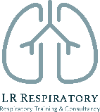
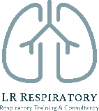
An Update in Asthma

3rd February 2021 12:30-2:45

Education provider: Kernow Health Training Hub
Training delivered by: Laura Rush, LR respiratory Training & Consultancy
www.lrrespiratory.com

Audience: This webinar is aimed at healthcare professionals that are that are already managing asthma patients in practice and are wanting an update.
​This meeting is supported by Chiesi UK Ltd. Chiesi will deliver a 10 minute presentation at the start of the webinar
​This webinar will cover:
- The importance of getting the right diagnosis
- The latest evidence and guidelines for asthma management
- The treatment options and tailoring treatment to the patient
- Tackling non adherence and reliever (SABA) inhaler overuse
- Recognising and managing exacerbations
- Supported self-management

The webinar will be hosted via MS Teams. The link will be sent out in advance of the meeting by Kernow Health Training Hub.

Throughout the webinar you will be expected to contribute to discussion and will be able to contribute and ask questions using the ‘chat feature’.

