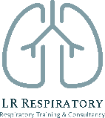
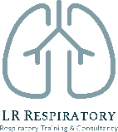
Remote Consultations for Asthma & COPD Reviews

20th January 2021 9:30-11:00

Education provider: Kernow Health Training Hub
Training delivered by: Laura Rush, LR respiratory Training & Consultancy
www.lrrespiratory.com

​Audience

The Covid-19 Pandemic has meant new ways of working, a reduction in face to face contact with patients and an increase in remote reviews. The aim of this webinar is to support healthcare professionals reviewing respiratory patients remotely by providing some practical tips and advice on carrying out asthma and COPD reviews over the telephone or by video.

These are fully funded places supported by Chiesi UK Ltd. Chiesi will deliver a 10 minute presentation at the start of the webinar.
​​

Webinar content
- An overview of remote consultations
- Pro's and cons of telephone and video consultations
- The use of software such as AccuRx
  - SMS
  - Sending documents
  - Video calling
- Working efficiently using data to risk stratify patients and prioritise care
- The remote annual review:
  - Assessing symptoms remotely: useful tools
  - Smoking cessation
  - Assessing inhaler technique and adherence
  - Managing anxiety related breathlessness: breathing techniques
  - Keeping active: remote resources
  - Rescue packs and management plans for exacerbation
  - Supported self-management
  - Navigating and signposting to useful online patient resources
​
Throughout the webinar you will be expected to contribute to discussion and will be able to contribute and ask questions using the ‘chat feature’.

The webinar will be hosted via MS Teams. The link will be sent out in advance of the meeting by Kernow Health Training Hub.

