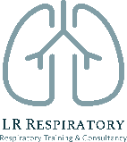
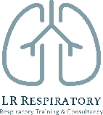
Paediatric Asthma Update

16th March 2021 12-1pm

Education provider: Kernow Health Training Hub
Training delivered by: Laura Rush, LR respiratory Training & Consultancy
www.lrrespiratory.com

Audience: This webinar is aimed at healthcare professionals that are that are already managing asthma patients in practice and would like an update in paediatric asthma.
​This meeting is supported by Teva UK Limited. Teva will deliver a 10 minute presentation at the start of the webinar.
​
This webinar will cover:
- A refresher: overview of paediatric asthma/epidemiology
- The latest guidance on diagnosing asthma in children:
  - What makes it more likely?
  - What about the under 5’s?
- Wheeze in early childhood:
- Episodic viral wheeze
- Multiple trigger wheeze
- The latest guidance on treating asthma in children
- The pharmacological and non-pharmacological management of asthma and rhinitis
- Overview of guidelines (BTS/SIGN guidance) and the differences
- Choosing an inhaler device and inhaler technique (practical session)
- Recognising and managing acute exacerbations.
- Action Plans and supported self-management

The webinar will be hosted via MS Teams. The link will be sent out in advance of the meeting by Kernow Health Training Hub.

Throughout the webinar you will be expected to contribute to discussion and will be able to contribute and ask questions using the ‘chat feature’.

