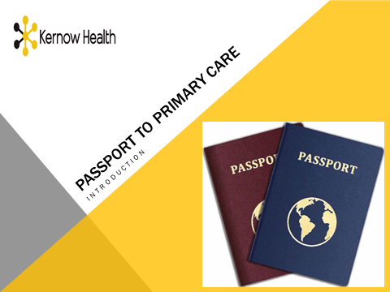
‘Passport to Primary Care’ is a Cornwall Primary Care Training Hub initiative, supporting access to primary care roles for newly qualified health care professionals/returners, those with previous experience in different health care fields, alongside those interested in non-clinical roles with no prior healthcare experience. It forms an ideal opportunity to develop portfolio roles across the health care system.
The ‘Passport’ programme offers core and optional multi-professional introductory training modules, after which participants can select from a range of further training opportunities from the Training Hub prospectus, according to individual needs, e.g. immunisation, wound care, diabetes, respiratory. Once skills and competencies are acquired, staff can register with the Kernow Staff Bank if desired, to acquire experience in primary care.
The training is delivered via a blended learning approach including e-learning and highly directed study followed by live interactive sessions involving presentations, case scenarios and quizzes to consolidate learning.
Core Topics - Combined 2-hour session (for all clinical and non-clinical staff)
- Service delivery in Primary Care:
  - Organisational structure of primary care, how services are provided, commissioned and regulated
- Safe practice in Primary Care:
  - Record keeping, confidentiality, consent, safeguarding and domestic abuse.
Optional Modules - Individual 1.5-hour sessions
- Person Centred Primary Care
- Making the most effective use of consultations
- How to achieve therapeutic partnership to enable self-care
- Long-term Conditions Management & Health Promotion in Primary Care
- Understanding long-term condition diagnosis, management and review in primary care.
- Health promotion e.g. Health Checks
- Primary Care Essentials for Non-medical Professionals (Nurses, AHP’s)
- Medicine management, scope of practice, lone working & training/competency assessment.

