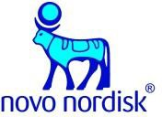
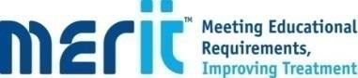
Virtual Meeting Via Teams Part 2

Pre-insulin treatment options for the management of type 2 diabetes
10th November 2020
Kernow Health CIC,1st Floor Cudmore House,Oak Lane,Truro,TR1 3LP
Speaker :
Kirsty Osborne , Diabetes Education Nurse Facilitator, Novo Nordisk Ltd
Dr Eddy Candy , Senior Regional Medical Advisor, Novo Nordisk Ltd
Emma Broome, Diabetes Specialist Nurse

14.00  5 Minutes | Welcome and IT check | Objectives of Module  Mentorship |  | Kirsty Osborne
14.05  20 Minutes | More recent pharmacological therapies | Incretin based therapies Background on incretin effect |  | Dr Eddy Candy
14.25  10 Minutes | More recent pharmacological therapies |  | DPP4 Inhibitors | Kirsty Osborne
14.35  15 Minutes | More recent pharmacological therapies |  | GLP1 Receptor Agonists | Emma Broome
14.50  15 Minutes | Device Workshop |  |  | Kirsty Osborne  Emma Broome
15.05  10 Minutes | Management guidelines for Type 2 Diabetes |  | NICE  ADA  EASD | Dr Eddy Candy
15.15  10 Minutes | Driving and the DVLA |  | Licence groups Informing DVLA  Type of Licence, treatment and hypoglycaemia | Emma Broome
15.25  5 Minutes | Monitor and Support |  | Why and when should treatment be reviewed ? Recording care | Kirsty Osborne
15.30  25 Minutes | Case Studies |  |  | Kirsty Osborne  Emma Broome
16.00 | Summary, Evaluations, Mentorship and Close |  |  | Kirsty Osborne

