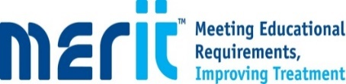

Diabetes Programme 2020 for Healthcare professionals, Kernow Health CIC

The MERITTM Programme has been developed by Novo Nordisk.

The aim of the programme is to support the development of skills and competency in the management of Type 2 Diabetes in the primary care setting in line with TREND competencies (https://diabetestimes.co.uk/wp-content/uploads/2019/03/Framework_5th_EDN_TREND.pdf).

What is the MERITTM programme?
MERIT™ (Meeting Educational Requirements Improving Treatment) is a two-part flexible class-room based education programme developed by Novo Nordisk. MERIT™ is a competency-based programme and is for all healthcare professionals involved in diabetes care.

The programme will combine the theory required to support diabetes management followed by the provision of tailored clinical support from specialist diabetes teams. It is recommended that all healthcare colleagues attend together to maximise learning opportunities back in practice.

MERIT™ was developed and funded by Novo Nordisk

Pre-insulin Treatment and Management of people with Type 2 Diabetes
Part (1) 10th November 2pm-4pm via TEAMS
Part (2) 24th November 2pm -4pm via TEAMS

This module provides an overview of diabetes therapy prior to insulin treatment and is suitable for all healthcare professionals involved in the management of diabetes who require updating with the latest guidelines and therapies
4 CPD Points

This programme has been accredited by the RCN Centre for Professional Accreditation

Accreditation applies only to the educational content of the programme and does not apply to any product.

