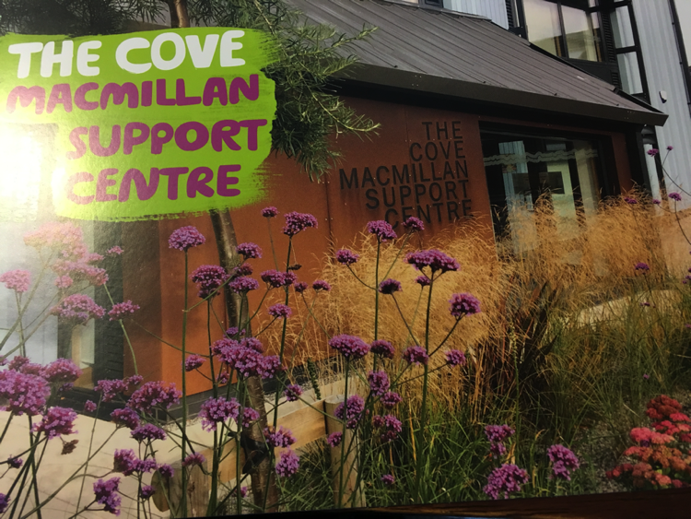

# To register email Judy Clapp Macmillan Primary Care Nurse Facilitator

# T

Cancer Awareness Training

Module 1 Introduction cancer awareness 24.11.20 1-2 pm

Module 2 Impact of cancer, Signposting 1.12.20 1-2pm

Module 3 Communication 8.12.20 1-2pm

Module

## 3 x1 hour modules

Invite to MMMMMasterclass

Virtual HCA /AP Training

To Book Email [Judith.clapp@nhs.net](mailto:Judith.clapp@nhs.net)

Judith.clapp@nhs.net