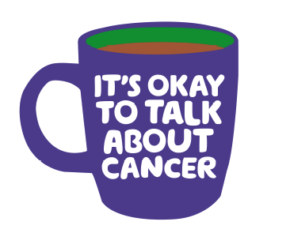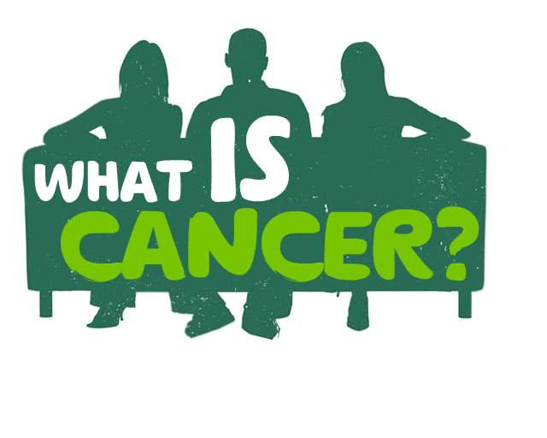

Reception and non clinical staff

Cancer Awareness and Communication Training



Module 1 Cancer Awareness 7th Oct 20 1-2pm Or 5th Nov 20 1-2pm

Module 2 Impact of cancer and signposting 14th Oct 20 1-2pm Or 12th Nov 1-2pm

Module 3 Communication 21st Oct 20 1-2pm Or 19th Nov 20 1-2pm

## Modules are aimed to improve confidence and knowledge around communication and signposting to those patients, carers and families affected by cancer. Modules will be offered over a month and repeated to make them easily accessible

Please register by emailing Judy Clapp Macmillan Primary Care Nurse Facilitator Judith.clapp@nhs.net

# 3 x 1 hour modules via Microsoft teams